CITY OF CARBONDALE, KANSAS

Mayor

Anthony DaPrato

President

Kevin Seals

Council

Cheryl Lister

Chad Moore

~~Kaitlyn Ball~~

Ronald Moeller

Attorney

Tom Barnes III

Employees

Emily Bessette

Shannon Seals

OFFICE OF THE

CITY COUNCIL



**CITY COUNCIL MEETING**

Date: May 19, 2025

Time: 7:00pm

Location: City Council Room, City Hall

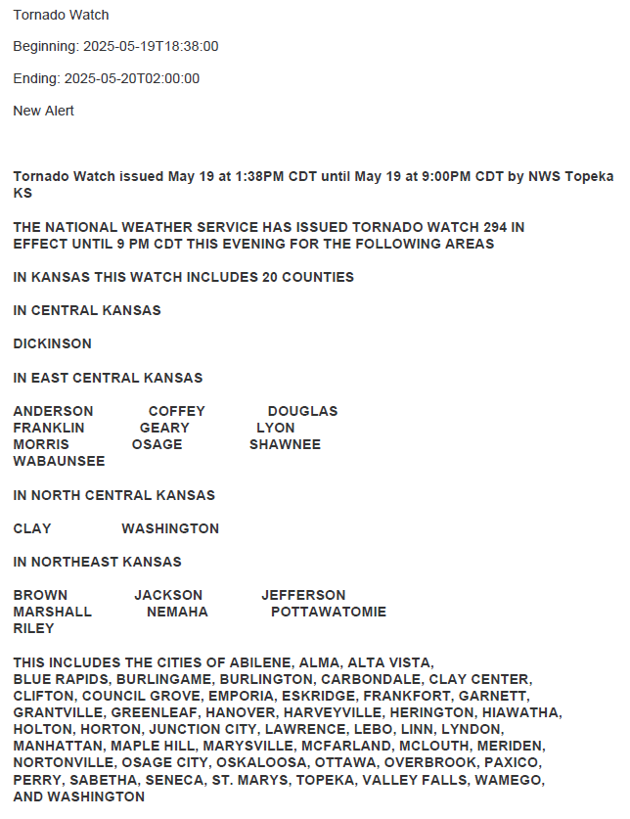ANNOUNCEMENT OF OPEN MEETING RECORDINGS: Any person may make a video or audio recording of an open session of a meeting, or may transmit the meeting through any medium, subject to reasonable requirements of the chair as to the number, placement and operation of equipment used so as not to interfere with the conduct of the meeting. Any person intending to make such a recording shall notify the Chair forthwith. All documents and exhibits used or referenced at the meeting must be submitted in duplicate to the City Clerk, as they become part of the Meeting Minutes. This information is also posted on the wall by the door for review.

